Edge Intelligence
25MML0043
Ganesh G
Using mobile device collected the required data for cnn model and splitting it to 70 – 30 percent
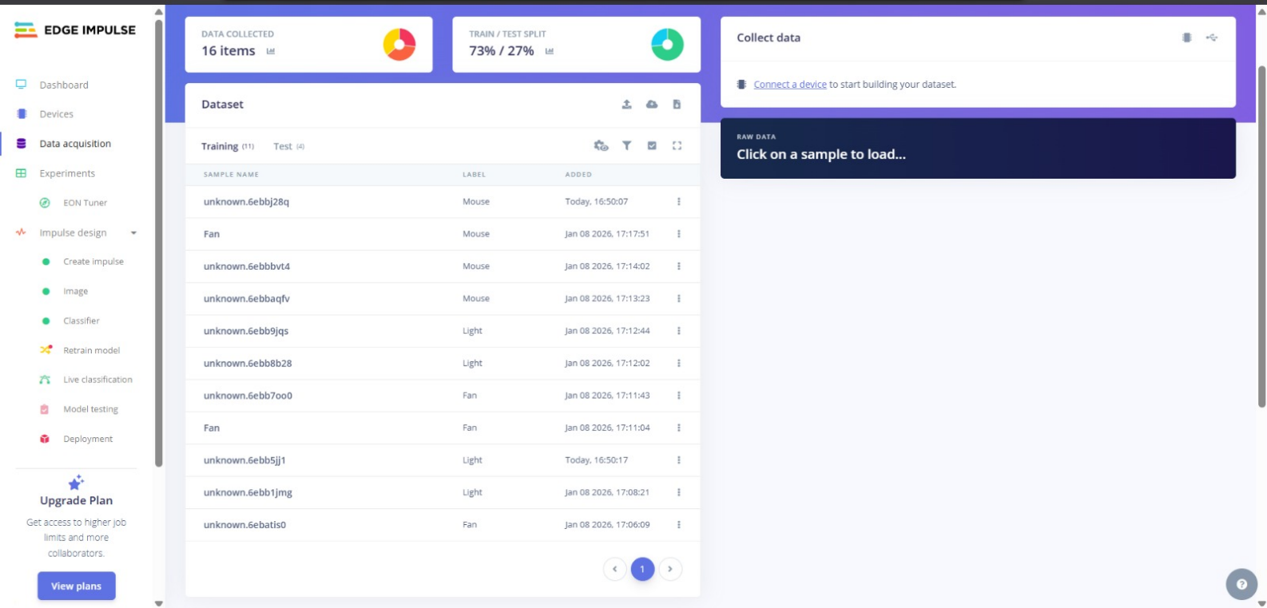
Choosing classification
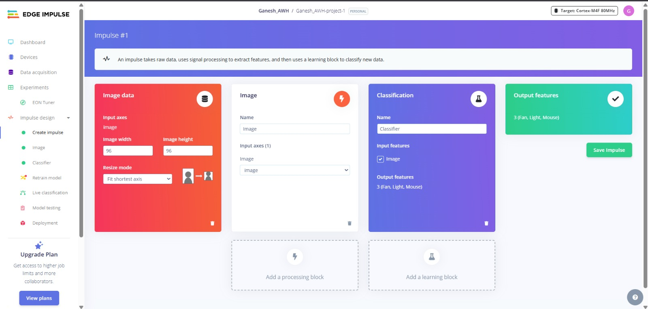
Generating features for the image
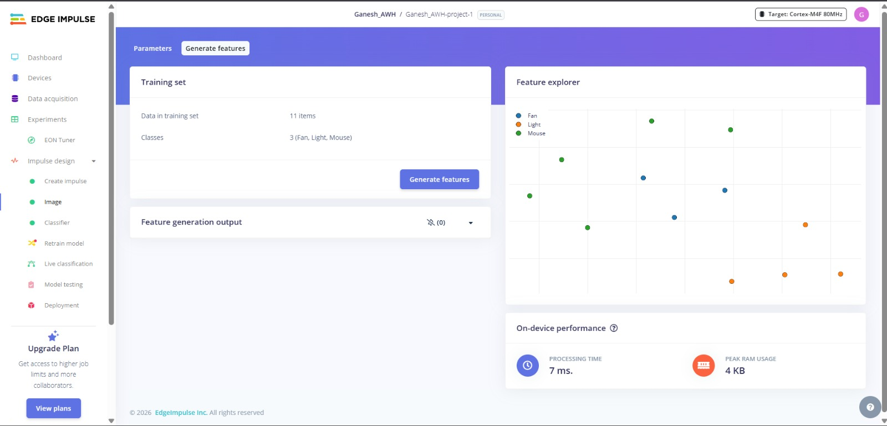
Training the real time data with cnn model
